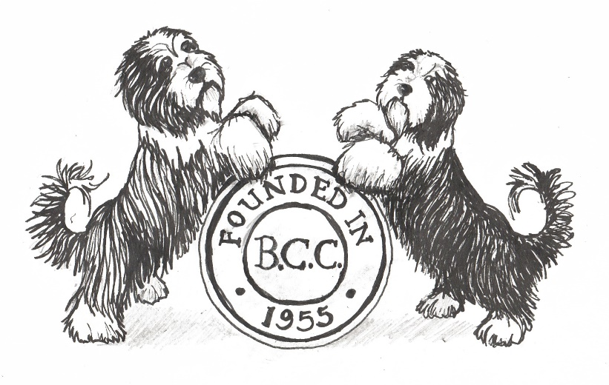
The Bearded Collie Club
PATRONS: | Mrs B Iremonger, Mrs B White | PRESIDENT: Miss P Brooks
CHAIRMAN: Mrs R Wood |  | VICE CHAIRMAN: Mr J Scott
ACTING TREASURER: Mrs S Carter |  | ACTING MEMBERSHIP SECRETARY: Miss V Rudd
SECRETARY: Ms Maureen Sale. 2 Moss Way, Streetly, Sutton Coldfield, West Midlands, B74 2BT
Tel. 0121 3537267 Email: secretary@beardedcollieclub.co.uk

The Bearded Collie Club’s Privacy Information

All queries and concerns about how the Club handles personal data should be directed to the BCC’s Secretary on the details above. The Secretary will then pass on the correspondence to the appropriate Officer or Committee Member best placed to your answer queries – contact details for various Committee posts can be found on www.beardedcollieclub.co.uk.

Personal Data held on Members

The Club holds contact information contained within the Bearded Collie Club's Membership list, which is held by the Membership Secretary and has to be maintained as part of Kennel Club expectations. The BCC take the responsibility for your data seriously and this list is held securely with the information purely used for the running of the Club – through post, email and telephone communication. This information is also shared with the Secretary of the relevant local Branch to enable them to communicate with their Members. Any Member who wishes to be an Associate Member of a different Branch can do so by communicating this with the relevant Branch Secretary.

The BCC does not share any Member’s data with commercial 3rd parties but as per Kennel Club rules the Membership list has to be available to any Club Member upon request. All Members have always had the right to withhold their information from this version of the list and can continue to exercise this right by contacting the Membership Secretary.

Yearbook

The BCC publishes an annual "Yearbook" which serves as an historical archive for the breed and Club to record the various activities and achievements of the Members. This record has been running since 1976 and the vast majority of information and personal details are provided and consented to during the submission process. There are two main elements:

1) Adverts & Roll of Honours – Members submit & proof read the details they wish to be printed
2) Information about general Club processes, including judging lists and Committee/Branch contact details – consent for these are gained separately from the relevant individuals and parties

However, the approved Membership list (minus Members wishing to withhold) has historically been printed in the Yearbook, both as an important archive and so that Members can contact each other. Under the new GDPR rules the printing of the list needs Member’s active consent because the Yearbook is available for sale to the general public despite being limited edition, only available via the Club and is bought by people actively involved in the Bearded Collies.

The Club takes your data privacy seriously and so will gain your initial consent before printing any version of the Membership list in the Yearbook. This consent can be given on the Yearbook order form and also as part of Membership renewal process. In addition the Club will undertake to refresh this consent as and when appropriate.

Information collected as part of events

The Club will periodically collect information as part of events and on the most part will automatically comply with the conditions laid out above. In the event that the personal data will be used for different purposes then this will communicated with the individuals at the point of collection. A key example would be entries made at Club shows, which are run according to KC requirements and the privacy information is provided in the schedule/catalogue or direct from Fosse Data.

